Optimal design of decentralized constructed wetlands treatment system under uncertainties

# Introduction

The purpose of this project is to showcase how an optimization model can be used to improve the

## Objective

This paper aims to determine the optimal configuration (location and size) of constructed wetlands in a specified area in Mobile, Alabama as a case study area.

# Literature Review

## Decentralised Wastewater Treatment Systems

Traditional wastewater treatment systems collect wastewater from households and are designed to handle large amounts of wastewater at a central location of the area it serves. With the implementation of centralized treatment systems in many countries, water pollution in those locations have been successfully controlled. However, such treatment systems often require technology that are expensive, such as membrane bioreactors. With growth of large cities, the cost of maintenance and operation of centralized wastewater treatment systems _____.

### Constructed Wetlands

# Progress made to date

## Model Formulation

## Case Study – Mobile, Alabama

### Data collected

#### Case study site

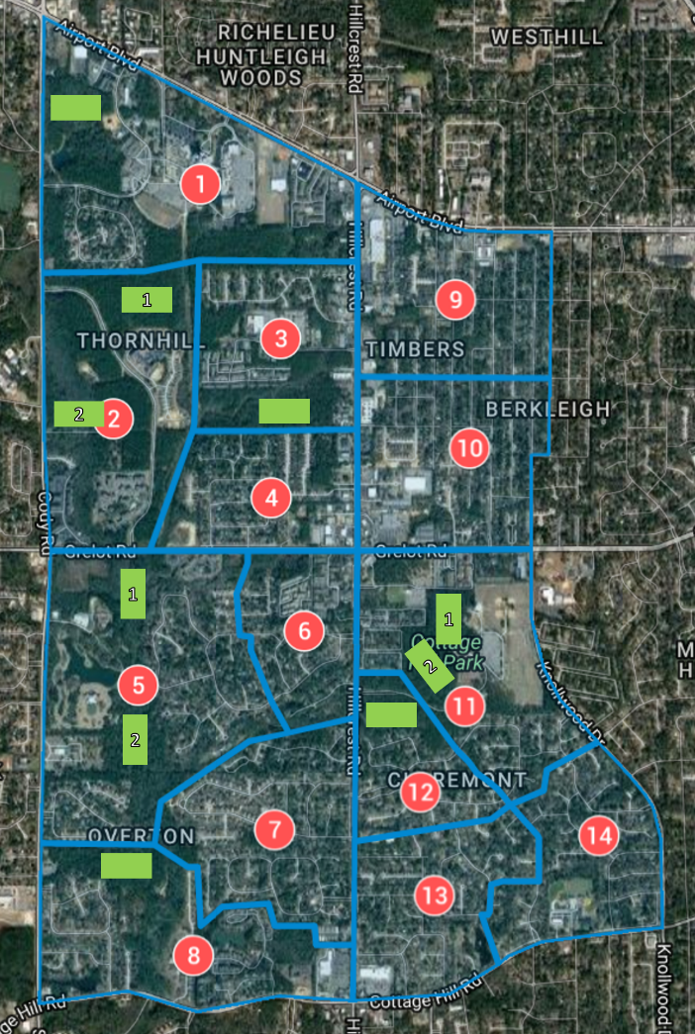The site chosen for the case study is near Mobile Regional Airport. It is a suburban area, mostly consisting of residences. As the objective of the project is to show how the optimization model can be applied, we have chosen a smaller area to keep the computation resources required reasonable. Hence, the site has been divided into 14 blocks based on six census tract blocks. Geographic information was also retrieved from the census. For each block, we have assumed a point source for the wastewater (see red circles).

(include table of geographic point, population, estimated wastewater flow)

Wastewater production for the region has been estimated based on the national average.

Potential sites for the constructed wetlands were identified from Google Maps and represented in Figure as green rectangles. These areas are empty and thus the construction of wetlands there will impact few residents negatively. A point location is used to represent each of these sites.

(Include table of geographic locations)

#### Pollutants

Once again, to keep the model manageable, we have narrowed down the number of pollutants to three:

|  |  |
| --- | --- |
| Pollutant | Indicator |
| Microorganisms | Biochemical oxygen demand over five days (BOD5) |
| Ammoniacal and organic nitrogen | Total nitrogen (TN) |
| Suspended solids | Total suspended solids (TSS) |

The pollutants have been selected based on the effects of pollution if these substances were not removed.

Explanation

### Deterministic model solution

# Future direction of study